The 10th International Conference of Him Science Congress Association organized at Hotel Moonglade, Banikhet Dalhousie was successfully concluded on 14th October 2023.
The focused of this two days conference was on Role of Science and Technology In Sustainable Development.
The conference was inaugurated by Mr. Pankaj Chowfla, a well renowned entrepreneur of District Chamba, H. P. In his inaugural address he highlighted the role of science and technology in the development of humankind.
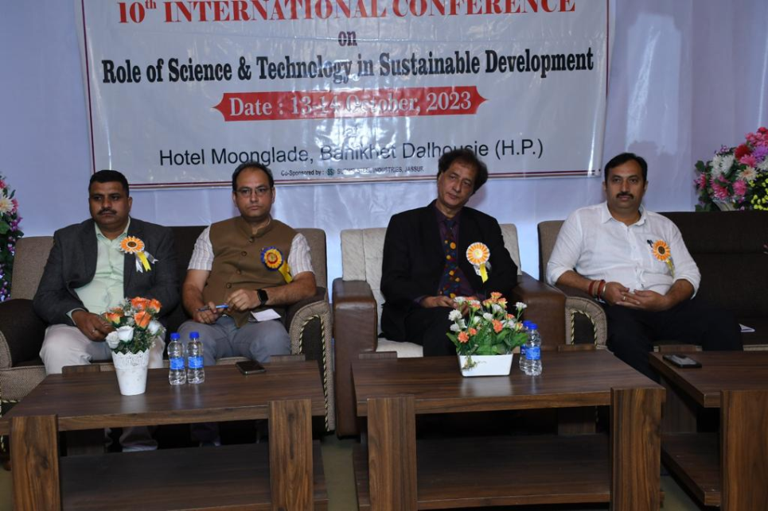
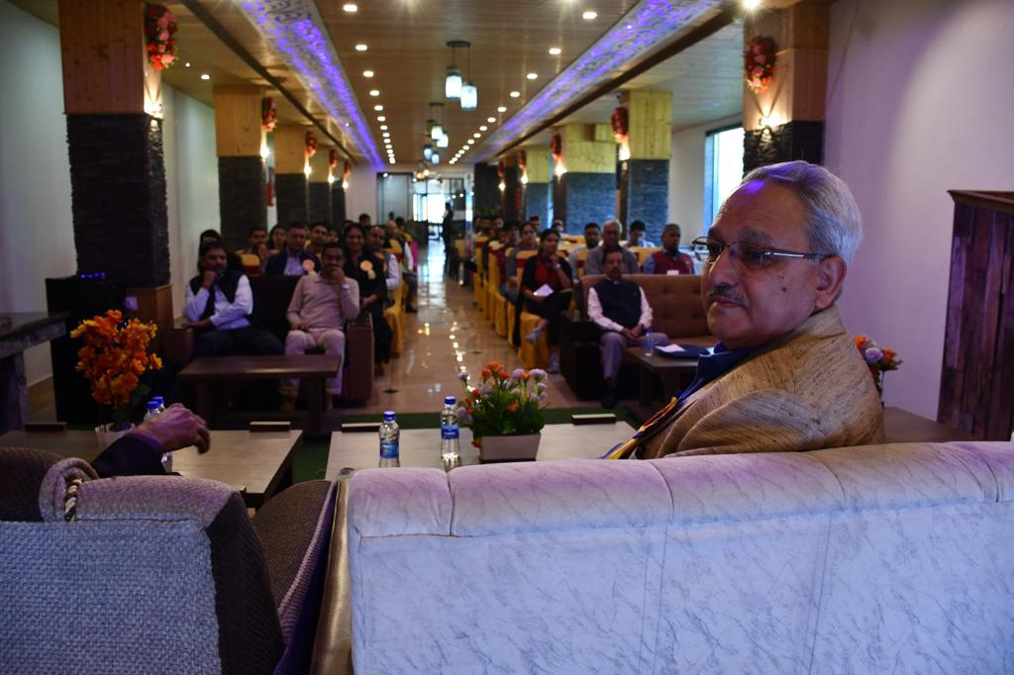
Professor Günther G. Scherer of Paul Scherrer Institute, Switzerland, was the the keynote speaker at inaugural session. Dr. Bilal Ahmad Mir and Dr. Tariq Maqbool of University of Kashmir, were among the other invited speakers.
The conference concluded on 14th October 2023 with the address by chief guest Prof. A. P. Vig, Chairman, Pollution Control Board Punjab. He motivated the researchers for clean environment and sustainable growth.
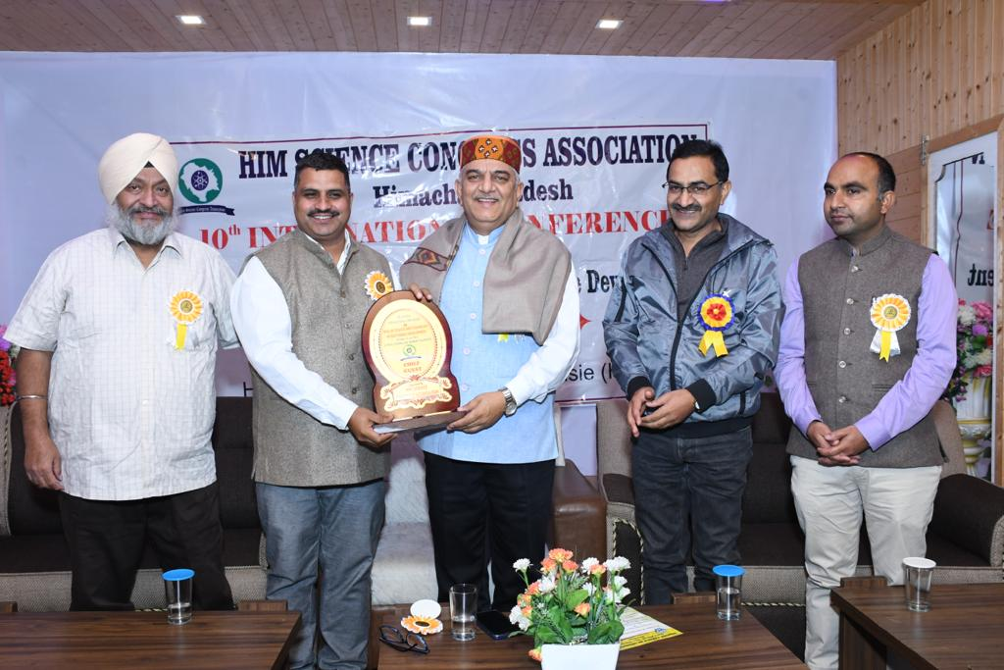
28 researchers presented their work in the form of oral presentation and 60 poster presentations were made during this conference. About 160 researchers participated in this conference. Jatin Chadha of Department of Microbiology, Panjab University, Chandigarh, was awarded with Young Scientist Award in the conference. Other than this, best presentations in each category were awarded in both oral and poster sections as mentioned in the table.
Section of the conference | Name of the presenter | Affiliation | Award
Chemical Sciences and Environmental Sciences | Dr. Rashmi Dhawan | S. A. Jain College, Ambala | Best oral presentation (First Prize)
 | Sarvjit Kaur | MMDU Mullana | Best oral presentation (Second Prize)
 | Vipula Sethi | IIT Delhi | Best Poster presentation (First Prize)
 | Mahika Gulati | NIT Jalandher | Best Poster presentation (Second Prize)
 | Krishma Kumari | CU Jammu | Best Poster presentation (Third Prize
Physical and Mathematical Sciences | Priya Mehra | CUHP | Best oral presentation (First Prize)
 | Sahil Bilaworia | University of Jammu | Best oral presentation (Second Prize)
 | Pradeep Kumar Ghosh and Alok Kumar Sarkar | Jadavpur University, Kolkata | Best Poster presentation (First Prize)
Biological and Agricultural Sciences | Gagandeep Kaur | CU Jammu | Best oral presentation (First Prize)
 | Sreshtha Devi | CUHP | Best Poster presentation (First Prize)
 | Manvi Sharma |  | Best Poster presentation (Second Prize)
Undergraduate students | Swati Sharma and Sweeti |  | Best Poster presentation

